Maintaining a WordPress website

Logging in
- To access the login page for your website, add “/wp-login.php” to the end of your website’s domain name.
For example: If your website’s domain is https://web.mercer.edu, the login page would be https://web.mercer.edu/wp-login.php
If you are unsure of your website’s domain, contact Digital Communications.
- Sign in with your Mercer University Azure AD account.
- If you are not already logged into Microsoft Online, you will see a screen like this:
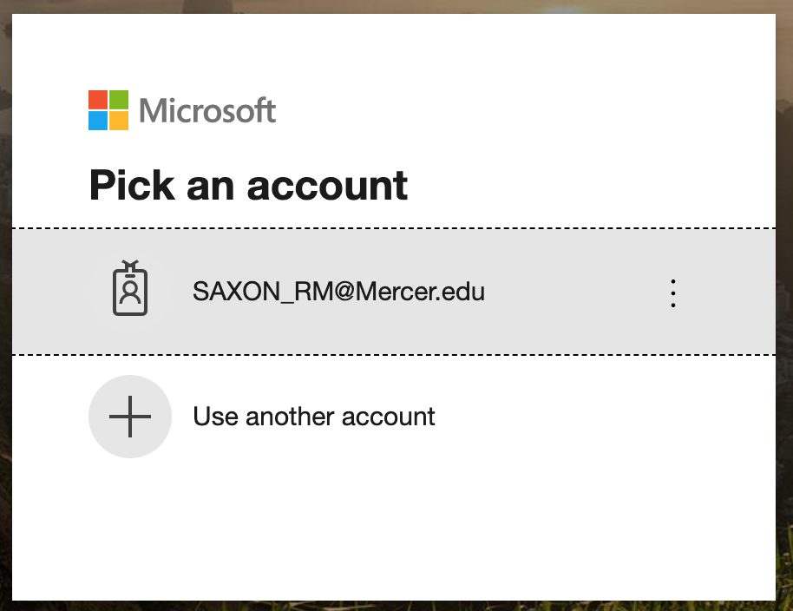
- Select the listing that matches your account.
- Enter your Mercer password.
- You can choose whether to stay signed in.

Using the WordPress dashboard
The dashboard gives you options to customize your site.
The main three menu items that you will need are:
- Pages > All Pages (This menu option is one way you can edit pages.)
- Appearance > Menus (This menu option is the best way to edit navigation.)
- Media

Understanding a web page
Webpages consist of three main editable sections: the hero, the modules, and the navigation.
- Hero: A large row of content under the header (usually a dark bar with graphics and white text)
Note: There is only one hero per page and its content is largely static.
- Module: A row of content on the page under the hero
Note: There can be multiple modules.
- Navigation: Menus with links to pages in your site

Selecting a page to edit
- In the WordPress Dashboard, select Pages > All Pages.
- From the list of pages, hover the mouse pointer over the page that you wish to edit and click the Edit link under the page’s title.
Note: There is another way to reach this view. If you are logged into WordPress, you can navigate to the page that you wish to edit, and there will be a black WordPress bar across the top of each page. Select ‘Edit Page.’

Editing a page

Hero
- Title: The main heading of your page
- Excerpt: The text under the title
- Image: A foreground photo
- Video: A link on the image to a video
- Background Image: A background photo
Custom Menu: An advanced section – consult with the Digital Communications team to edit

Modules
There are 23 types of modules, but five common modules are:
- Content – WYSIWYG
- Block Orange Background Full
- Block Featured
- Block Content
- Related Links

Content – WYSIWYG
This is the most widely-used module. It provides a simple, Microsoft Word-like content area.
Note: Often, the content will not appear in the editor until you click in it. If the content looks like code, click the visual tab to see the formatted content.

Features
- Editor
- Columns: The layout can support up to 4 columns in this module (each with a separate editor).
- Padding: The module’s top padding, the bottom padding, or both are removable.

Block Orange Background Full
Full-width section that uses a photo on an orange background.

Features
- Title: Module heading
- Excerpt: Title subtext
- Button Text: Label for the button
- Button URL: The address of the page visited when a visitor clicks the button
- Padding: The module’s top padding, the bottom padding, or both are removable.

Block Featured
Full-width section that uses a photo on a black or white background (selectable).

Features
- Background Option: The background can be black with white text or a white background with black text
- Background Image: Photo in the background of the module
- Title: Module heading
- Excerpt: Title subtext
- Button Text: Label for the button
- Button URL: The address of the page visited when a visitor clicks the button
- Image: Foreground photo
- Padding: The module’s top padding, the bottom padding, or both are removable.

Block Content
Full-width section that uses a button and a photo on a white background.

Features
- Multiple rows can be added to this module. The photos in each row will alternate from left side to the right side
The following fields are customizable in each row of this module:
- Title: Module heading
- Excerpt: Title subtext
- Button Text: Label for the button
- Button URL: The address of the page visited when a visitor clicks the button
- Image: Foreground photo
- Padding: The module’s top padding, the bottom padding, or both are removable.

Related Links
Full-width section that uses a button and a photo on a white background.

Features
- Title: Module heading
- Subtitle: Title subtext
- Padding: The module’s top padding, the bottom padding, or both are removable.
- Multiple links can be added to this module. The links are a grid of buttons.
The following fields are customizable in each row of this module:
  - Link Text: Button label
  - Link URL: The address of the page visited when a visitor clicks the button

Publishing Changes
Once a page is modified, use the ‘Update’ button to apply the changes.
When the ‘View Page’ link appears near the top of the page, click the link to see the changes.
Note: This system uses page caching to improve site performance. As a result, it may take up to 60 seconds for the changes to appear.

Adding Images to the website
Each website has a media gallery that stores a collection of files, mostly photos.
Note: It is very important to read the specific dimensions (height and width in pixels) that are given in the description of each image field. Before adding an image to the gallery, it should be cropped and resized to fit those dimensions.
- From the Dashboard sidebar, select Media
- Click the ‘Add New’ button
- Drag and drop files into the dashed area or choose ‘Select Files’
Note: You can add multiple files at once.

Placing an image on the page
IMPORTANT: Any media added to a website must be the property of Mercer
University or used with permission from the owner of the media.

To add an image to a page, there are two main ways:
- An image field. This is the preferred method because image layout is more consistent.
- Inline into a WYSIWYG content block

Image field
- Click the ‘Add Image’ button
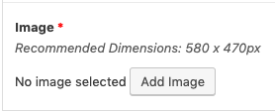
- Select the photo from the gallery
- Review the Alt text. The text should describe the image as if someone with an inability to see asked you to describe the photo.
- Click the ‘Select’ button
Note: If there is no appropriate image in the gallery, you can use the upload tab to add images. Also, if you wish to change an image, you will need to remove the previous photo before adding the new one.

WYSIWYG (What you see is what you get)
In a content editor, you can add an image
- Use the ‘Add Media’ button above the content area.
Follow steps 2-4 above.

Understanding Navigation
There are two types of menus:
- Blue Menu – The blue menu is used on landing pages. The content of landing pages is all full width. There is no sidebar column. The blue menu floats underneath the header. Note: The blue menu is limited to two levels of navigation.
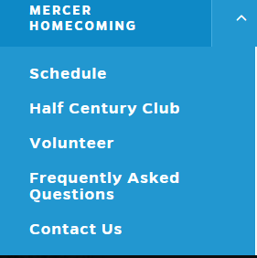
- Sidebar menu – The sidebar menu is for interior pages.
Note: These menus have the advantage of supporting more than two levels of navigation.
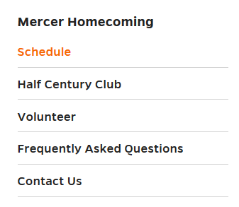

Adding a new page
There are three ways to add a page to your site:
- In the WordPress bar, select New > Page
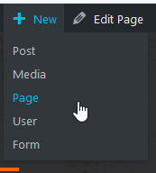
- In the WordPress Dashboard, Select Pages > Add New in the menu or the ‘Add New’ button on the ‘Pages’ page.
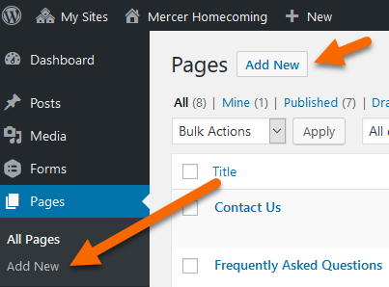
On the new page:
- Give the page a title. This will also be part of the web address. Spaces will replaced with dashes.

- Set the Page Attributes
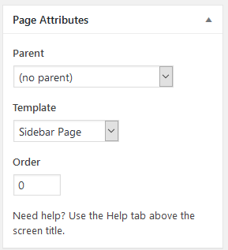
- Select a template. Select Sidebar Page. (most common choice)
- Add a hero. There are 5 options in the Add Hero list. Unless you are making a new home page (landing page), you will select ‘Interior Page.’
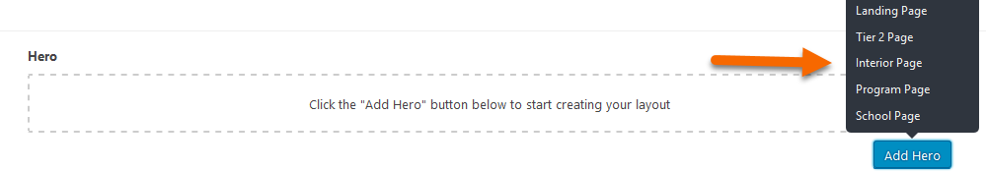
- Skip Custom Menu
- Modules – Since this uses the Sidebar Page template, there are few modules offered at the top of the page. Most people will probably use the Content – WYSIWYG option.
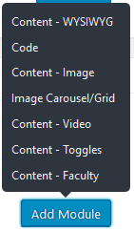
Note: You can add multiple modules here. Full-width modules are available at the bottom of the page (footer), underneath the sidebar nav.

- When changes are finished, click ‘Publish.’
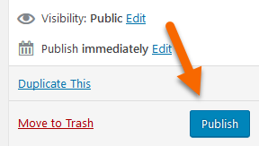

Adding a page to a menu
Note: Before a page can be added to a menu, it must be created in the site.
- The menus are accessible under the ‘Appearance’ heading in the dashboard.
- Locate the page title in the ‘Most Recent’ tab of the ‘Add to Menu’ window.
- Check the title of the page that will be added to the menu.
- Click the ‘Add to Menu’ button.
- Drag the new item to the appropriate place in the menu tree. Note: New items always appear at the bottom of the menu item list.
- Click the ‘Save Menu’ button.

Adding a link outside of your site to a menu
- Locate and expand the ‘Custom Links’ option under the ‘Add to Menu’ window.
- Add the web address in the ‘URL’ field.
- Add the menu label in the ‘Link Text’ field.
- Click the ‘Add to Menu’ button.
- Drag the new item to the appropriate place in the menu tree.
- Click the ‘Save Menu’ button.

